**EXPERIMENT – 1**

**EXP NO 1: CREATE A SIMPLE CLOUD SOFTWARE APPLICATION AND PROVIDE IT AS A SERVICE USING ANY CLOUD SERVICE PROVIDER TO DEMONSTRATE SOFTWARE AS A SERVICE (SAAS).**

**DATE:**26/09/25

**AIM:**

To create a simple cloud software application and provide it as a service using

any cloud service provider to demonstrate software as a service (saas).

**PROCEDURE:**

**STEP1:** GOTO ZOHO.COM

**STEP 2**: LOGIN TO THE ZOHO.COM

**STEP 3**: SELECT ONE APPLICATION

**STEP 4**: ENTER APPLICATION NAME

**STEP 5**: CREATED NEW APPLICATION

**STEP 6**: SELECT ONE FORM

**STEP 7**: THE SOFTWARE HASE BEEN CREATED**.**

**OUTPUT:**

**FORM 1 – Patient Details Form**

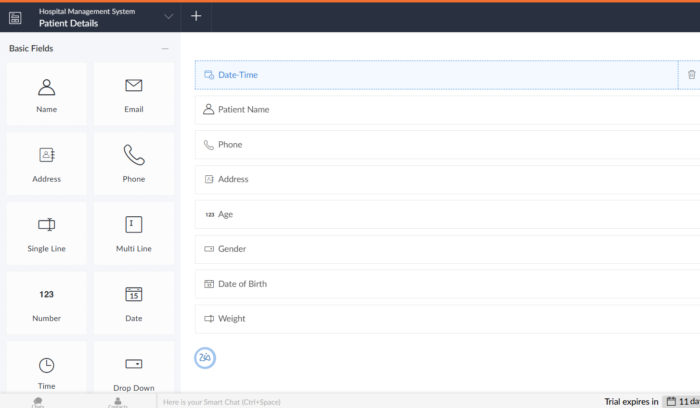

**FORM 2 – Prescription Form**

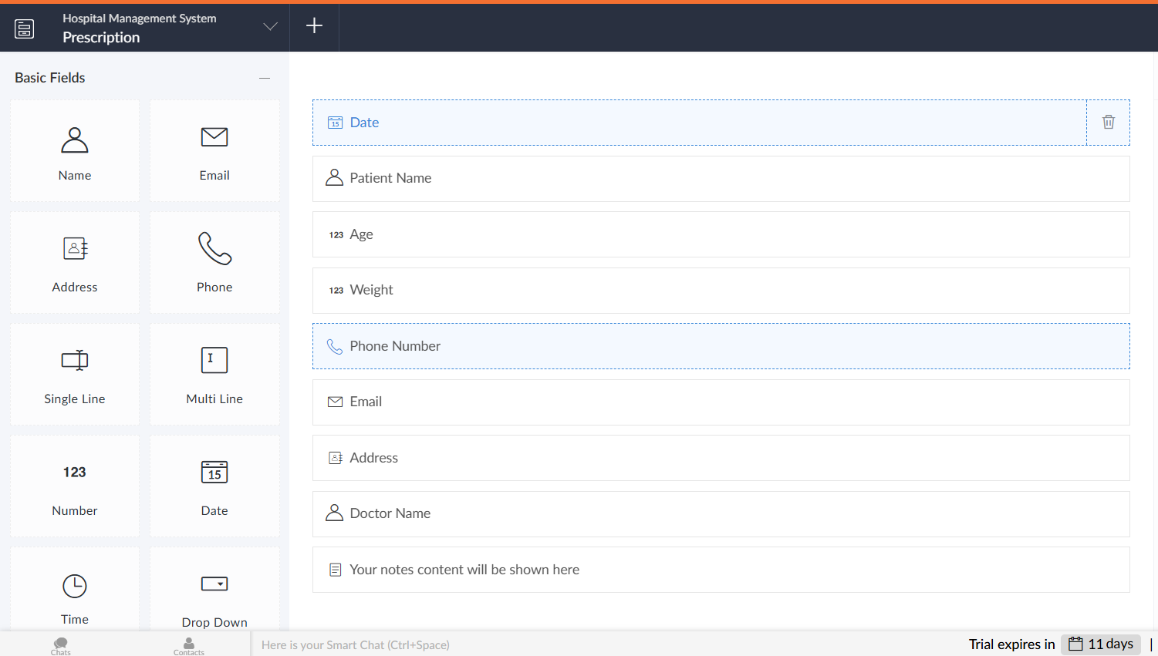

**FORM 3 –Diagnosis Form**

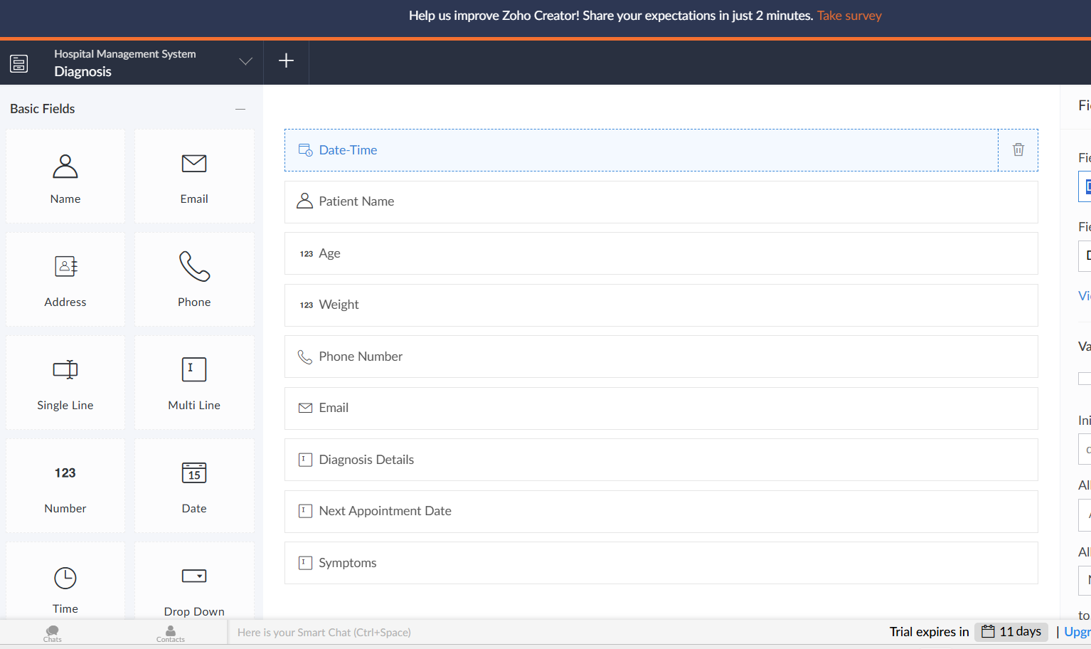

**FORM 1 –Patient Details Form**

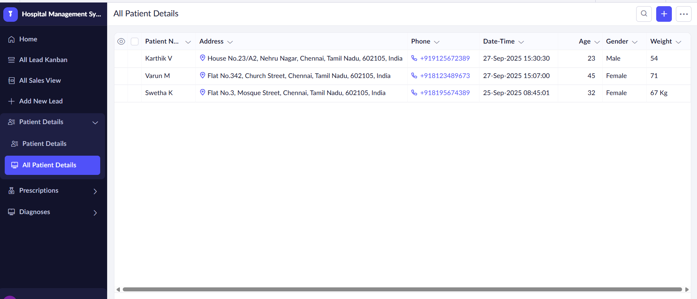

**FORM 2 – Prescription Form**

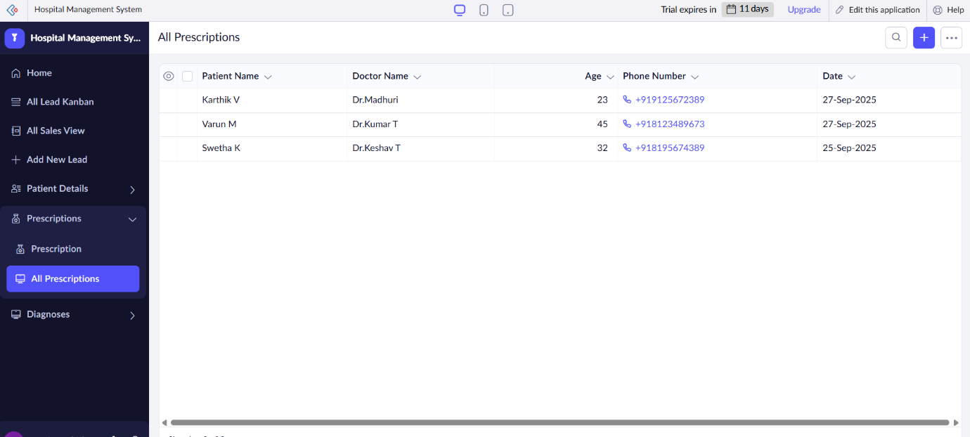

**FORM 3 –Diagnosis Form**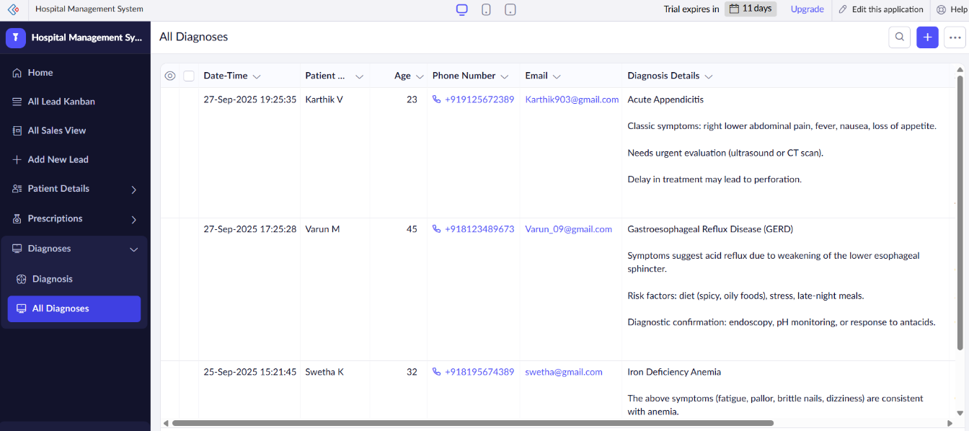

**RESULT:**

Thus, a **Hospital Management System** application was successfully created using **Zoho Creator (Cloud SaaS platform)** with the forms:

* **Patient Details Form**
* **Prescription Form**
* **Diagnosis Form**

This demonstrates **Software as a Service (SaaS)**, where the hospital staff and patients can access the system anytime through the cloud without installing any software.